Q1) The Trial balance of Kathmandu Traders showed the following accounts at December 31, 2023
Particulars | Dr Amount | Cr Amount
Store supplies | 3,500
Equipment | 1,05,000
Cash | 37,700
Accounts Receivable | 33,700
Merchandise inventory | 43,000
Accumulated Depreciation-Equipment |  | 49,000
Return Inward | 6,200
Cost Of goods sold | 5,05,400
Salaries expenses | 1,10,000
Advertising expenses | 26,400
Utility expenses | 14,000
Repair expenses | 12,100
Delivery expenses | 16,700
Rent expenses | 24,000
Delivery Van | 38,000
Common Stock |  | 80,000
Retained earnings |  | 30,000
Dividends | 12,000
Sales Revenue |  | 7,57,200
Acc- Depreciation – Delivery Van |  | 12,000
Notes Payable |  | 65,000
Account Payable |  | 19,800
Supply expense | 5,300
Depreciation expense | 20,000
Interest expense | 5,000
Interest Payable |  | 5,000
Income tax expense | 5,000
Income tax payable |  | 5,000
Total | 10,23,000 | 10,23,000
Required : Multi Step Income Statement and Classified Balance Sheet as on 31st December 2023.
2. The Trial Balance of a Kabeli Company as on Ashadh 31, 2079 is given below:
Particulars | Debit (Rs.) | Credit (Rs.)
Cash in hand | 1,00,000
Cash at bank | 2,54,000
Discount allowed | 2,000
Plant and machinery | 2,20,000
Purchases | 1,50,000
Accounts receivable | 65,000
Interest on loan | 4,000
Salary expenses | 50,000
Prepaid rent | 20,000
Capital stock |  | 3,00,000
Accounts payable |  | 50,000
Discount received |  | 15,000
Sales revenue |  | 4,00,000
Bank loan |  | 1,00,000
Total | 8,65,000 | 8,65,000
Adjustment:1. Closing stock Rs. 50,000
- Prepaid rent expired was Rs. 2,000
- Outstanding interest on bank loan was Rs. 4,000
- Depreciation on plant and machinery at 10% per annum.
Required: Income statement and Balance sheet.
3.
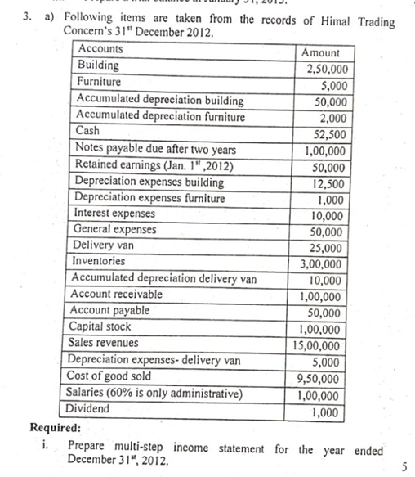
4. 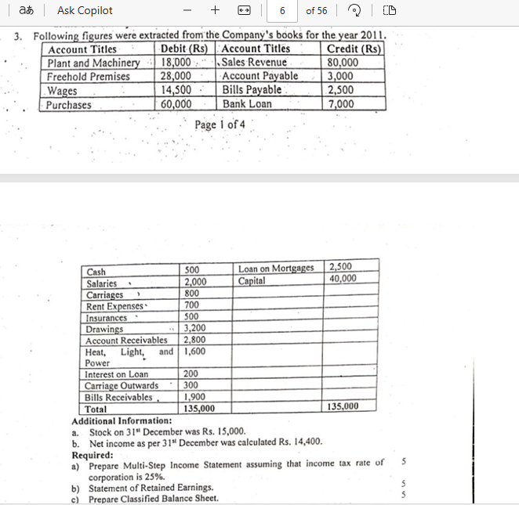
5. 